Image Zooming
After we have cropped a sub image from the original image we can zoom in on it by enlarging it. The zoom process can be done in numerous ways:
1. Zero-Order Hold.
2. First _Order Hold.
3. Convolution.

Zero-Order hold: is performed by repeating previous pixel values,
thus creating a blocky effect.
Example: if we have an image of size(n*n), we can zooming it using zero order method with size (2n)*(2n)

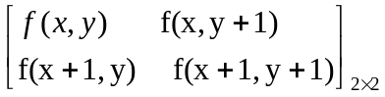

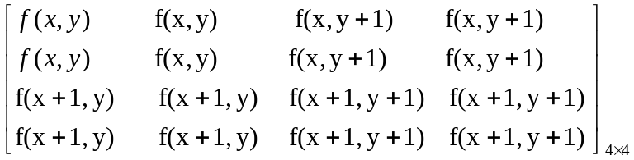
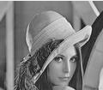
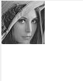
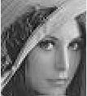
a-Original image b- cropped image c- zoomed imag

First _Order Hold: is performed by finding linear interpolation between a adjacent pixels, i.e., finding the average value between two
pixels and use that as the pixel value between those two, we can do
this for the rows first as follows:
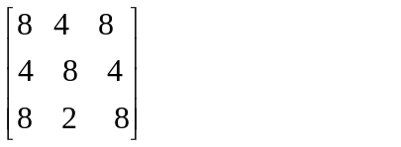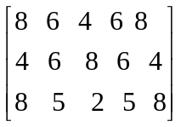

The first two pixels in the first row are averaged (8+4)/2=6, and this
number is inserted between those two pixels. This is done for every pixel pair in each row. Next, take result and expanded the columns in the same way as follows:
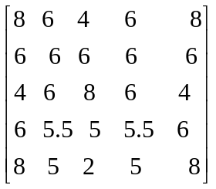
This method allows us to enlarge an N×N sized image to a size of (2N-1) ×(2N-1) and be repeated as desired.
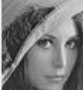
Original image cropped image zooming image

Convolution: this method requires a mathematical process to enlarge an image. This method required two steps:
1. Extend the image by adding rows and columns of zeros
between the existing rows and columns.
- Perform the convolution. The image is extended as follows:
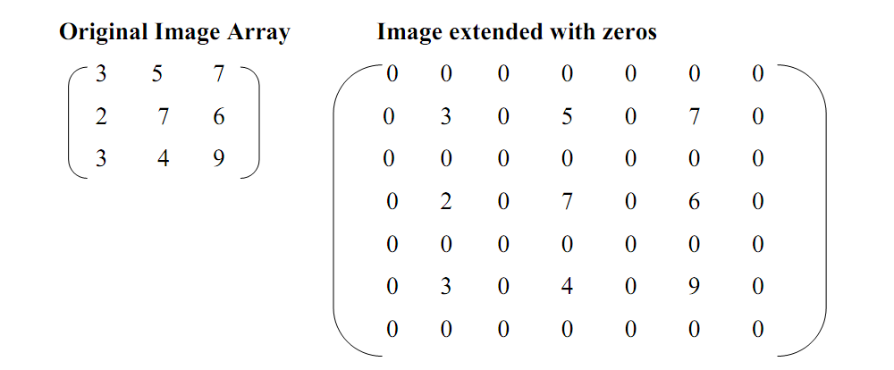
Next, we use convolution mask, which is slide a cross the extended image, and perform simple arithmetic operation at each pixel location .
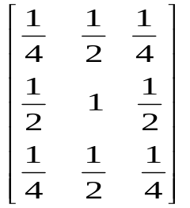
The convolution process requires us to overlay the mask on the image,
multiply the coincident values and sum all these results. This is
equivalent to finding the vector inner product of the mask with underlying sub image. The vector inner product is found by overlaying mask on subimage. Multiplying coincident terms, and summing the resulting products.
For example, if we put the mask over the upper-left corner of the image, we obtain (from right to left, and top to bottom):
1/4(0) +1/2(0) +1/4(0) +1/2(0) +1(3) +1/2(0) + 1/4(0) +1/2(0) +1/4(0) =3
Note that the existing image values do not change. The next step is to slide the mask over by on pixel and repeat the process, as follows:
1/4(0) +1/2(0) +1/4(0) +1/2(3) +1(0) +1/2(5) + 1/4(0) +1/2(0) +1/4(0) =4
Note this is the average of the two existing neighbors. This process
continues until we get to the end of the row, each time placing the result of the operation in the location corresponding to center of the mask.
When the end of the row is reached, the mask is moved down one row, and the process is repeated row by row. This procedure has been performed on the entire image, the process of sliding, multiplying and summing is called convolution.
Note that the output image must be put in a separate image array called a buffer, so that the existing values are not overwritten during the convolution process.

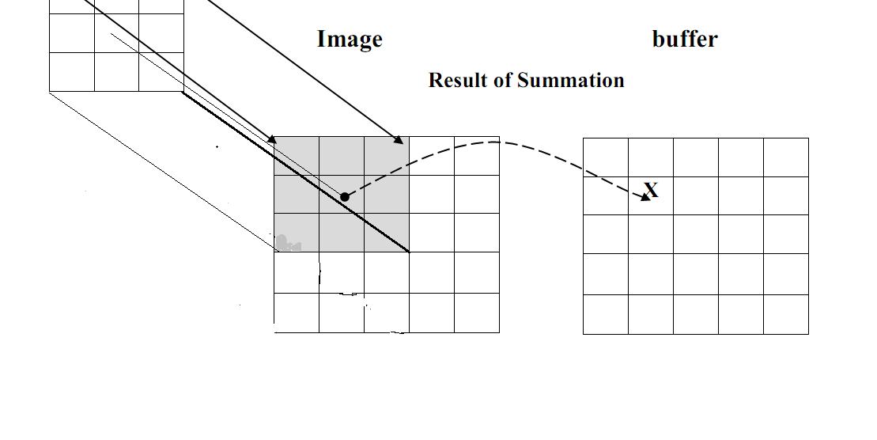
- Overlay the convolution mask in the upper-left corner of the image. Multiply coincident terms, sum, and put the result into the image buffer at the location that corresponds to the masks current center, which is (r,c)=(1,1).
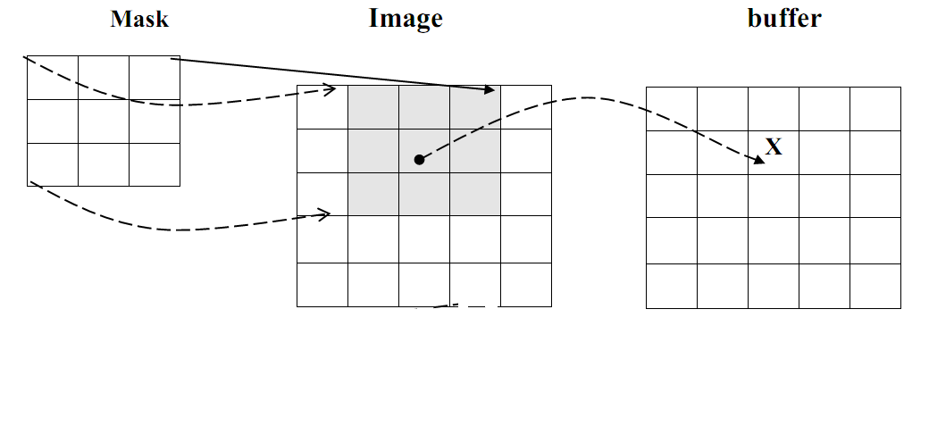
- Move the mask one pixel to the right , multiply coincident terms sum , and place the new results into the buffer at the location that corresponds to the new center location of the convolution mask which is now at (r,c)=(1,2), continue to the end of the row.
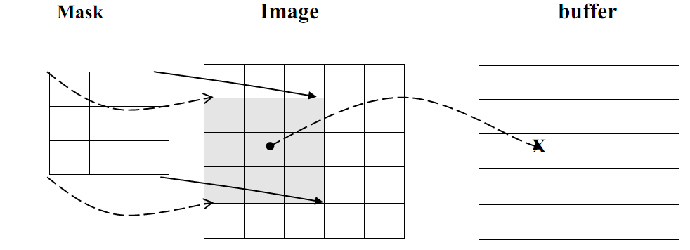
- Move the mask down on row and repeat the process until the mask is convolved with the entire image. Note that we lose the outer row(s) and columns(s).
At this point a good question would be Why we use this convolution method when it require, so many more calculation than the basic averaging of the neighbors method?
The answer is that many computer boards can perform convolution in hardware, which is generally very fast, typically much faster than applying a faster algorithm in software.
Not only first-order hold be performed via convolution, but zero-order hold can also achieved by extending the image with zeros and using the following convolution mask.
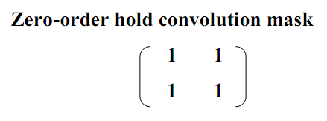
Note that for this mask we will need to put the result in the pixel location corresponding to the lower-right corner because there is no center pixel.
These methods will only allows us to enlarge an image by a factor of (2N-1), but what if we want to enlarge an image by something other than a factor of (2N-1)?
To do this we need to apply a more general method. We take two adjacent values and linearly interpolate more than one value between them. This is done by define an enlargement number k and then following this process:
1. Subtract the result by k.
2. Divide the result by k.
3. Add the result to the smaller value, and keep adding the result from
the second step in a running total until all (k-1) intermediate pixel
locations are filled.
Example: we want to enlarge an image to three times its original size, and we have two adjacent pixel values 125 and 140.
1. Find the difference between the two values, 140-125 =15.
2. The desired enlargement is k=3, so we get 15/3=5.
3. next determine how many intermediate pixel values .we need :
K-1=3-1=2. The two pixel values between the 125 and 140 are
125+5=130 and 125+2*5 = 135.
• We do this for every pair of adjacent pixels .first along the rows and
then along the columns. This will allows us to enlarge the image by
any factor of K (N-1) +1 where K is an integer and N×N is the image
size.
• To process opposite to enlarging an image is shrinking. This process is done by reducing the amount of data that need to be processed.
• Two other operations of interest image geometry are: Translation and Rotation. These processes may be performed for many application specific reasons, for example to align an image with a known template in pattern matching process or make certain image details easer to see.

